TMA/BECTU Code of Conduct Sample Loading Plan

This truck plan sample uses software downloadable from the web. However, it is perfectly acceptable to hand-draw a loading plan after the get-out and simply put it in the truck, attached to the inside of the rear doors. This then ensures that the loading plan is accurate and available throughout the tour.

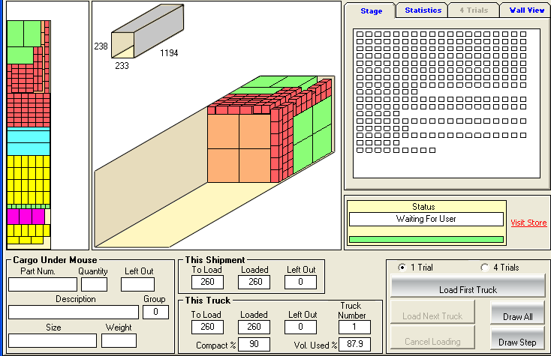 Row 1
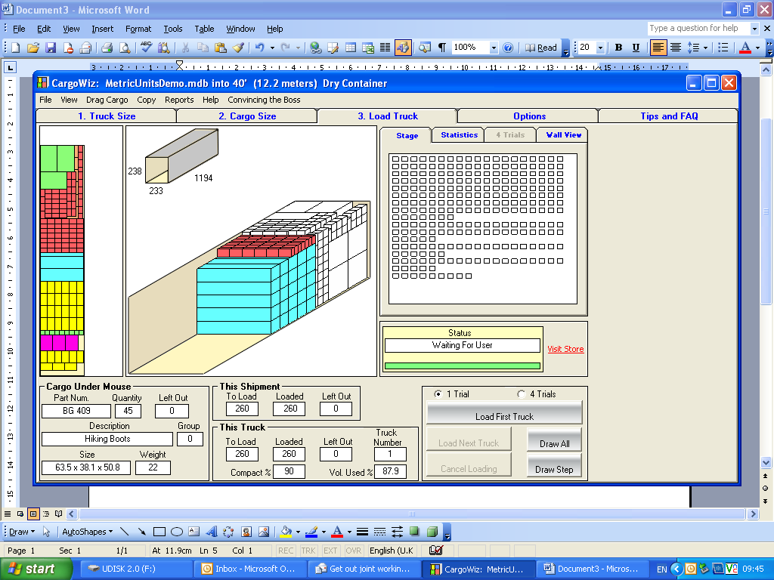 Row 2
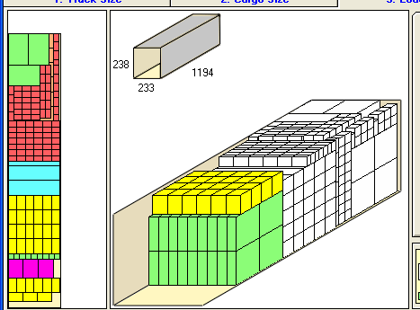 Row 3
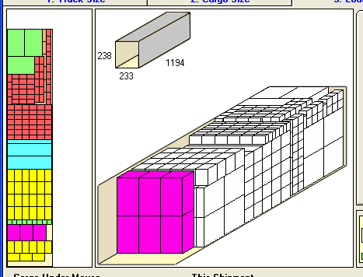 Row 4
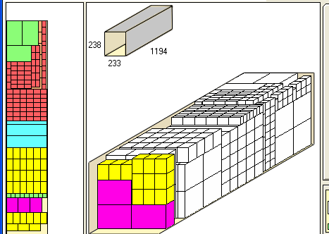 Row 5
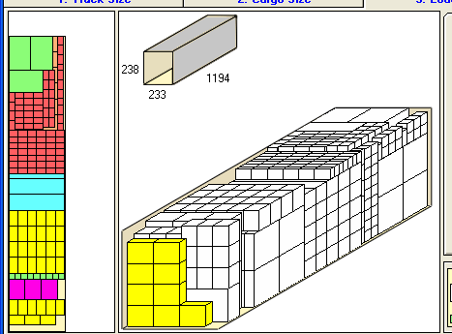 Row 6

